DRAFT ATTACHMENT AE.1
LINEAR UNDERGROUND AND OVERHEAD PROJECT (LUP) AREA OR SEGMENT AREA TYPE DETERMINATION
NATIONAL POLLUTANT DISCHARGE ELIMINATION SYSTEM (NPDES)
GENERAL PERMIT FOR STORMWATER DISCHARGES ASSOCIATED
WITH CONSTRUCTION AND LAND DISTURBANCE ACTIVITIES
(GENERAL PERMIT)

Part 1
- Will ≥ 70% of the construction activity occur on paved surfaces or will < 30% of the soil disturbance occur on unpaved surfaces?
  - If Yes, proceed to question 2
  - If no, proceed to question 3
- Will areas disturbed be returned to pre-construction condition or equivalent condition at the end of the day?
  - If Yes, this is a Project Type 1 LUP
  - If No, proceed to Part 2 on page 3
- Will the construction activity occur on unpaved improved roads, including their shoulders or land immediately adjacent to them?
  - If Yes, proceed to question 5
  - If No, proceed to question 4
- Will > 30% of the construction activity occur within the non-paved shoulders or land immediately adjacent to paved surfaces?
  - If Yes, proceed to question 5
  - If No, proceed to Part 2 on page 3
- Will areas disturbed be returned to pre-construction conditions or equivalent condition at the end of the day?
  - If Yes, proceed to question 6
  - If NO, proceed to Part 2 on page 3

- Will areas of established vegetation disturbed by the construction be stabilized and revegetated by the end of the project?
  - If Yes proceed to question 7
  - If No, proceed to Part 2 on page 3
- When required, will adequate temporary stabilization BMPs be installed and maintained until vegetation is established to meet the Permit’s minimum cover requirements for stabilization?
  - If Yes, this is a Project Type 1 LUP
  - If No, proceed to Part 2 on Page page 3

Part 2
- 1. Calculate the Sediment Risk per Appendix Attachment D.1 or the Stormwater Multiple Application and Report Tracking System (SMARTS).
Project Sediment Risk =
LOW: < 15 tons per acre; or
MEDIUM: ≥ 15 and < 75 tons per acre; or
HIGH: ≥ 75 tons per acre
- 2. Is the project area or project segment area located within a Sediment Sensitive Watershed (Refer to Appendix Attachment D.1 or SMARTS)?
  - If Yes, proceed to question 2
  - If No, Receiving Water Risk is LOW
- 3. Is the project area or segment located within the flood plain or flood prone area (riparian zone) of a Sensitive Receiving Water Body?
  - If Yes, Receiving Water Risk is HIGH
  - If No, Receiving Water Risk is MEDIUM
Use the below combined risk matrix to determine the site-specific type for the linear underground and overhead project.
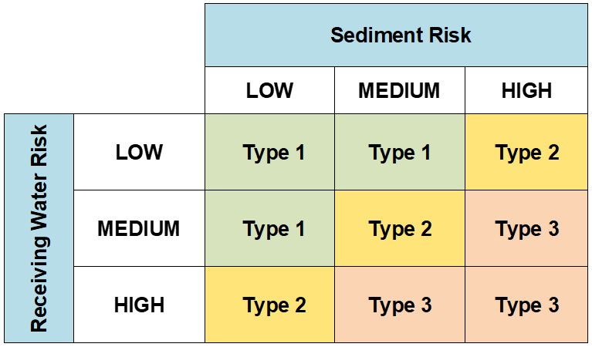

Definition of Terms
Equivalent Condition – Means disturbed soils such as those from trench excavation are required to be hauled away, backfilled into the trench, and/or covered (e.g., metal plates, pavement, plastic covers over spoil piles) at the end of the construction day.
Linear Construction Activity – Defined in Attachment AE of this General Permit.
Sediment Sensitive Receiving Water Body – Defined as a water body segment that is listed on the State Water Board’s approved Clean Water Act 303(d) list for sedimentation/siltation, turbidity, or is designated with beneficial uses of COLD, SPAWN, and MIGRATORY.
Sediment Sensitive Watershed – Defined as a watershed draining into a receiving water body listed on the State Water Board’s approved CWA 303(d) list for sedimentation/siltation, turbidity, or a water body designated with beneficial uses of COLD, SPAWN, and MIGRATORY.
Total Maximum Daily Load (TMDL) – A TMDL is the sum of the maximum amount of a pollutant that a waterbody can receive per day and still meet water quality standards. The water bodies and/or watershed with U.S. EPA-approved or U.S. EPA established TMDLs, listed in Attachment H of this General Permit, are considered high risk.

