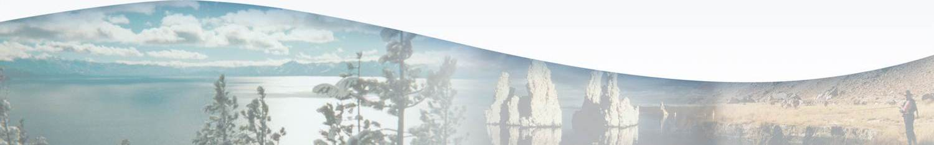
Lahontan Water Board Program Fact Sheet
FY 2017-18
Surface Water Ambient Monitoring Program (SWAMP)
Overview
The Surface Water Ambient Monitoring Program (SWAMP) is a statewide monitoring effort designed to assess the conditions of surface waters throughout the State of California. The program is funded by the Waste Discharge Permit Fee (WDPF) . SWAMP seeks to monitor the status and trends in water quality for all surface waters (lakes, streams/rivers, wetlands, coastal waters) as well as targeted monitoring to answer specific regional questions.
SWAMP has two primary components: 1) “regional” monitoring led by the Regional Water Boards; and 2) statewide surveys led by the State Water Board. SWAMP also supports the development, deployment, and maintenance of a statewide database, the California Environmental Data Exchange Network (CEDEN), to permanently store surface water monitoring data collected by all entities throughout California. SWAMP staffing is 2 PY (down from 3.5 PY in FY 2015-2016).
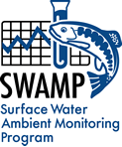
Key Efforts

- Collect ambient water quality data to assess long-term trends and determine impairments. Prepare a report on the quality and health of the Lahontan Region’s surface waters.

- Implement the second year of a three-year bioassessment sampling effort to assess the biological and physical integrity of the Region’s streams and rivers. Staff will focus on the Region’s long-term SWAMP sampling sites, water bodies with sedimentation issues, data gaps, and reference sites.

- In response to Harmful Alagal Blooms (HABs), determine if human health is protected in cases of water contact recreation through field indicator bacteria monitoring. HAB response is a new effort initiated in 2017.

- Ensure all SWAMP data is collected and managed using statewide quality assurance and quality control standards. After this internal review, regional data is available on CEDEN for the public to access. Begin to modernize our regional website with data assessment tools, and a more user-friendly design and useful format.

- Redesign the region’s SWAMP monitoring plan to be as useful and efficient as possible, while adjusting to staff reductions and changing responsibilities. SWAMP is currently evaluating opportunities to collaborate with other regional programs, statewide programs, and stakeholders to better utilize all available resources.

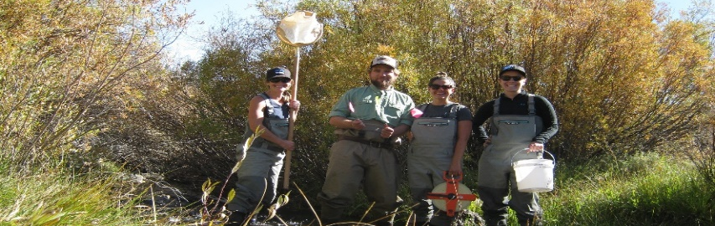
Accomplishments
- SWAMP staff visited 144 sites and conducted 350 water quality collections. All data is made available in the California Environmental Data Exchange Network (CEDEN), and assessed in the State Water Board’s “Integrated Report” (i.e., Clean Water Act Section 303(d)/305(b) assessment). Statewide and historical Region 6 SWAMP performance measures are available at: http://www.waterboards.ca.gov/about_us/performance_report_1516/plan_assess/12111_swamp_visits.shtml
- Updated regional website with the most recent fish consumption advisories and resources for regional data collectors. Access to SWAMP reports and data is available at: www.waterboards.ca.gov/lahontan/water_issues/programs/swamp
- During 2016-17, the Region’s SWAMP staff conducted a toxicity study for the Susan River with the California Department of Fish and Wildlife and the UC Davis Aquatic Health Program Laboratory. The 2017 UC Davis authored report, available on the SWAMP website, concluded that there is less toxicity than past studies and the Susan River is on the mend.
- Collected fish tissue samples from Fallen Leaf Lake, Big Pine Creek, Independence Creek, and Bishop Creek for developing fish consumption advisories. Results are expected summer 2018.
- Established our first in-house bioassessment sampling team. With assistance from contractors, Water Board staff sampled 20 sites in the first year of a three year effort.
- Funded and organized a training for data collectors interested in uploading data into CEDEN. The Marine Pollution Studies Laboratory provided the training, guiding data managers through the CEDEN data submittal process. The training was recorded and is posted on the SWAMP website.
- Coordinated with the Region’s TMDL Unit to adjust SWAMP sampling to obtain data needed to address impairments at 303(d)-listed water bodies.
Performance Targets for FY 2017-18
To ensure that SWAMP results are timely and easily accessible to Water Board staff and the public:
1) Make available on CEDEN at least 50 percent of SWAMP-funded data within one year of sample collection
2) Make available on CEDEN at least 95 percent of data within two years of sample collection. Including laboratory analyses, quality assurance checks (i.e., data verification and validation), and data transfer.
The Region’s SWAMP program has met its performance targets for all prior years, and expects to continue meeting the targets going forward.

Unaddressed Work
- Sampling to inform key management issues. These include:
- Focused data collection to determine effects of climate change.
- Additional sampling in headwaters to assess long-term changes in water quality and flows to protect state’s water supply.
- Assessment of minimum flows needed to maintain beneficial uses. Increased sampling events (ten sampling events per site/annually, recommended) at long-term monitoring sites to better capture seasonality of long-term sites.
- Historical SWAMP workload cannot be sustained due to staffing loss.
- Increasing responsibilities for Harmful Algal Blooms and regulatory support without additional resources.

