Attachment 1 – Directions for enrolling in the Stormwater Industrial General Permit

The State Water Resources Control Board (State Water Board) adopted the new Stormwater Industrial General Permit (IGP) on April 1, 2014 (2014-0057-DWQ) with an effective date of July 1, 2015. A broad range of industrial facilities are required to obtain IGP coverage to comply with federal regulations.
All information regarding the IGP, including a FAQ and working in SMARTS, is available on the State Water Board website at these Web Addresses:
#1: https://www.waterboards.ca.gov/water_issues/programs/stormwater/industrial.html
#2: https://smarts.waterboards.ca.gov
#3: https://www.waterboards.ca.gov/water_issues/programs/stormwater/smarts/industrial/indst_help_guides.shtml

All dischargers that operate facilities covered by the IGP are categorized by a Standard Industrial Classification Code (SIC) in Attachment A in the permit (click open Industrial General Permit at Web Address #1). Industrial establishments, categorized by an appropriate SIC code, are required to submit either a new IGP application, referred to as a Notice of Intent (NOI), or a No Exposure Certification (NEC) certifying that no industrial pollutants associated with their industry are exposed to stormwater. A few facilities may be situated or capture runoff such that they do not discharge in the largest events. These facilities might qualify for a Notice of Non-Applicability (NONA). See more about each below.

The IGP enrollment forms are electronic, you will need to use the State Water Board’s Storm Water Multiple Application and Report Tracking System (SMARTS) on-line database to apply for a permit via computer-internet connection using Edge, Chrome, or Internet Explorer 11 browsers (e.g., PCs with Windows 7 or 10). All applications must be submitted through SMARTS at Web Address #2.

Initially for any type of enrollment the Legally Responsible Person (LRP) must create an account in SMARTS (see guidance Web Address #3). As part of the account the LRP enters the operator and facility information in SMARTS. Once that has begun, you can follow one of the following paths as appropriate for your operations. More guidance to help you enroll is provided at Web Address #3 or through SMARTS Resources when you first open SMARTS. The Industrial Help Guides provide several step-by-step instructions (static image shown below).

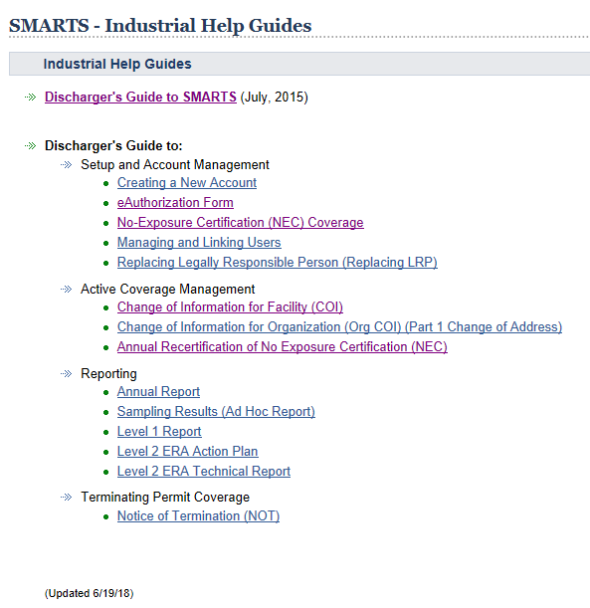

From the basic NOI information entry, the LRP and Data Entry Persons can complete the enrollment using the following guidance. We are unable to provide an exact path to compliance since we cannot conduct a thorough facility inspection of your establishment. Please contact the regional staff for your location to help you determine your exact path to compliance and whether your facility may qualify for a No Exposure Certification (NEC) or Notice of Non-Applicability (NONA). Here are the three enrollment options allowed by the IGP.

NOTICE OF INTENT (NOI) AND STORM WATER POLLUTION PREVENTION PLAN (SWPPP)
Industrial operations categorized by Standard Industrial Classification (SIC) codes listed in Attachment A that discharge to a Water of United States or tributary and exposed to rainfall and runoff must enroll and prepare the Permit Registration Documents. More detailed information about SIC codes is available by selecting Permit Coverage at Web Address #1. The enrollment process includes preparing a Storm Water Pollution Prevention Plan (SWPPP) and electronically filing a Notice of Intent (NOI) in SMARTS for compliance with the Industrial Storm Water General Permit (refer to Attachment D at Web Address #1). The full NOI fee is $1,400 (invoiced annually during the yearly quarter of initial application). Registration, uploading a SWPPP and map, and final certification of the NOI are due now for operating facilities and within 7-days of operation for new facilities.

Instructions on how to Sign up and register in SMARTS and file the Notice of Intent are available at Web Address #3 to view a series of Electronic Reporting guides.
(Click open Discharger’s Guide to SMARTS link and follow guidance starting on page 20).
To apply for IGP coverage, you must:
- Identify the Legally Responsible Person (LRP)
- Have the LRP “sign-up” and register to create an account in the SMARTS database using Edge, Chrome, or Internet Explorer 11 browsers.
- Enter the New User account details and security questions.
- Print the Electronic Authorization form, sign in blue ink, and mail to State Water Board at the address provided on the form.
- Once certified, the LRP will receive an account confirmation email with a temporary SMARTS login password.
- Once the LRP receives a temporary password, the LRP can log into SMARTS to Link other registered users (e.g., Duly Authorized Representative, Data Entry Person).
- Follow the Guide to SMARTS Database section 4.0 New Notice of Intent (NOI) starting on page 20 to enter contact, facility, and billing information.
- Select the Attachments tab and click “Upload Attachment” and upload the SWPPP and a separate Facility Site Map (follow directions on pages 24-25 of the Guide to SMARTS Database).
- Perform Completion Check under the Certification tab to certify and submit (certify) the Notice of Intent and Permit Registration Documents electronically in SMARTS. Only the LRP can certify the NOI.
- Consistent with this option, you are required to develop and implement a Facility/Site Map (per section X.E on pages 26-27) and Storm Water Pollution Prevention Plan (SWPPP) specific to the operations of your facility (see IGP Section X, page 24) and comply with other requirements of the IGP. Additional guidance can be found in EPA’s SWPPP development guidance document (http://www.epa.gov/npdes/pubs/industrial_swppp_guide.pdf ) or the California Storm Water Quality Association (CASQA) Industrial and Commercial BMP Handbook (available by subscription at https://www.casqa.org/resources/bmp-handbooks/industrial-commercial).

If your facility has all industrial activity protected from rain or runoff exposure or cannot under any circumstance discharge to a creek or storm drain you might qualify for either...
NO EXPOSURE CERTIFICATION (NEC)
You can read the NEC Brochure for more information (Web Address #1 click open: Resources – Industrial General Permit Toolbox). For the NEC, please review the Instructions for No Exposure Certification (see Web Address #3 IGP Appendix 2) especially page 3 (see #3 What is the Definition of No Exposure a–e). Once you’ve reviewed the Instructions for No Exposure Certification and you believe your facility qualifies for the NEC, please follow the steps for obtaining NEC coverage starting on page 26 of Discharger’s Guide to SMARTS (Web Address #3). The fee for the NEC is $150 and requires annual recertification and fee. Registration, uploading a map, and final filing of the NEC are due now for operating facilities and within 7-days of operation for new facilities.

NOTICE OF NON-APPLICABILITY (NONA)
For the NONA please refer to section 6.0 (page 30) of the Discharger’s Guide to SMARTS (Web Address #3) for directions to process it in SMARTS. Note there is no fee for the NONA, but you are required to enter your information in SMARTS and upload a professional engineer’s certified Technical Report that demonstrates your facility does not discharge to Waters of the United State during the historical maximum precipitation events. We have decided that the NONAs are due now for operating facilities and within 7-days of operation for new facilities.

Here are a few main items that need to be considered for the NONA:
- The facility must not discharge any stormwater to a Water of the United States.
- The NONA Technical Report should consider and include the maximum historical 1-day, 1-week, 30-day, 365-day periods of rainfall based on historical data with a significant length of record (~20-30-year minimum). These values shall be calculated on a running basis such that the period is not summed by calendar weeks/months/years and instead on a running total basis. For sites where stormwater will be included as part of the treatment works (which may have a maximum capacity design rate e.g. MGD), an analysis of runoff peak flow rate must also be included in the report such that the maximum historical rate of runoff is considered. Appropriate hydrologic methods must be used to determine the peak flow rates associated with the maximum historical rainfall rate using the historical data (i.e., CANNOT simply divide 1-day total by 24 to get in/hr.). For example, if the historic 1-day rainfall was 6 inches in a day, the Rational Method or similar appropriate method should be used to determine the peak flow rate that would be expected and added to the headworks of the treatment train. The end goal is that “no discharge” of storm water, under any circumstance, may leave a site claiming NONA.
- In the Technical Report, confirm that any stormwater held on site would not threaten or contribute to groundwater pollution (per section II.S.3 – Additional Considerations, Fact Sheet page 72; whole IGP pdf pg. 151).
- Please contact Central Water Board staff if you have questions about calculating the maximum historical precipitation events.

If the IGP requirements apply to your facility, it is imperative that you complete the NOI process as soon as possible to avoid non-compliance enforcement actions.

SMARTS works best with Windows 10 PCs using the Edge Browser. SMARTS also works with Windows 7 PCs using Chrome and Internet Explorer 11 browsers. SMARTS does not operate correctly on Macintosh computers (Safari) or PCs using Mozilla Firefox, Netscape, other PC browsers, or smart phones.
NEC Brochure available at: http://www.swrcb.ca.gov/water_issues/programs/stormwater/docs/toolbox/nec_brochure.pdf

