REGULATORY IMPEDIMENT GAP ANALYSIS TOOL 

BENCHMARK/OBJECTIVE | CODE REFERENCE AND SUMMARY OF EXISTING STANDARD | GAP BETWEEN EXISTING STANDARD AND BENCHMARK (OPPORTUNITY TO IMPROVE)
Street Width
Is the minimum pavement width allowed for streets in low density residential developments that have less than 500 daily trips (ADT) between 18 and 22 feet?

At higher densities, are parking lanes also allowed to serve as traffic lanes?

Is a single, shared travel lane to serve traffic flowing in both directions permitted in low volume single family residential neighborhoods?
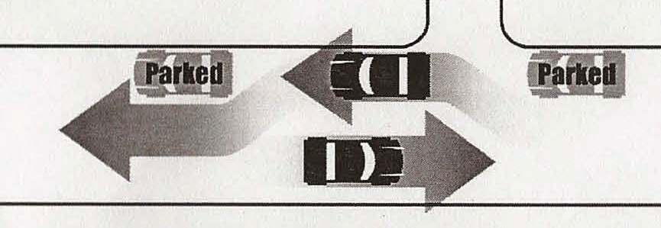

Street Length
Do street layout standards promote the most efficient street layouts that reduce overall street lengths and impervious surfaces?

Right of Way Use
Does code allow for utilities to be placed under paved section of the ROW?

Cul-de-Sacs
Does the minimum allowable cul-de-sac radius exceed 35 feet? Is the minimum radius greater than 45 feet?

Can a landscape island be created within the cul-de-sac?
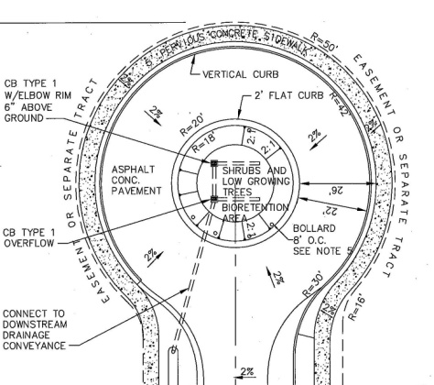

Are alternatives turnarounds such as "hammerheads" allowed on short streets in low density residential developments?
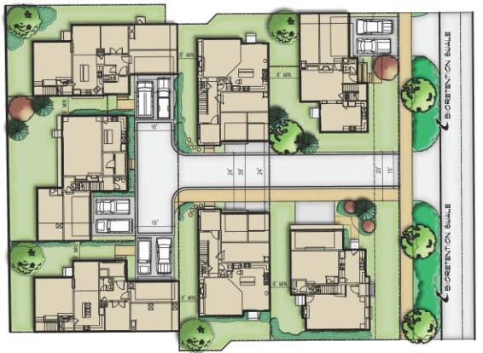

Street-side Bioretention
Are curb and gutters required for most residential street sections?
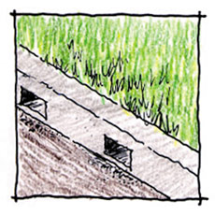

Do adopted street sections allow for the use of open treatment and conveyance of stormwater within landscape strips?

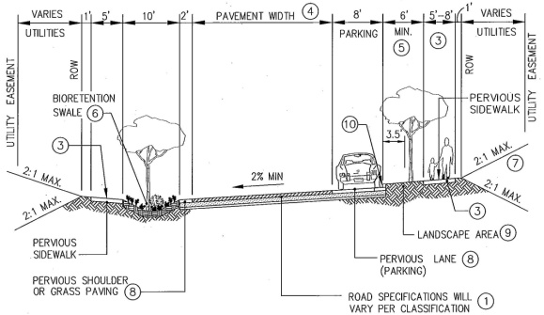

Land Conservation Incentives
Are there any incentives for developers or landowners to conserve non-regulated land (e.g., open space designs, density bonuses, stormwater credits, etc.)?

Is flexibility to meet regulatory or conservation restrictions (e.g., density compensation, buffer averaging, transferable development rights, offsite mitigation, etc.) offered to developers?

Structured Parking
Are there any incentives for developers to provide parking within garages rather than surface parking lots?

Parking Ratios
Do maximum parking standards exist in addition to minimum standards?

Is the minimum parking ratio for single family homes (per home) less than or equal to 2 spaces?

Is the minimum parking ratio for a professional office building (per 1,000 sf of gross floor area) less than 3 spaces?

Is the minimum requires parking ratio for shopping center (per 1,000 sf gross floor area) less than 4.5 spaces?

Parking Codes
Are model shared parking agreements provided?

Are parking ratios reduced if shared parking arrangements are in place?

If mass transit is provided nearby, may the parking ratio reduced?

Parking Lot Runoff
Is a minimum percentage of a parking lot required to be landscaped?

Is the use of bioretention islands and other stormwater practices within landscaped areas and/or setbacks allowed?
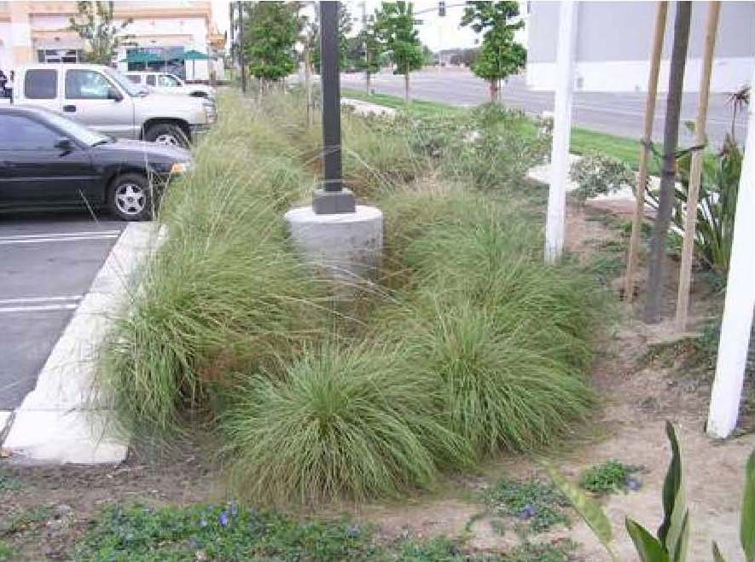

Does your design manual specify a requirement designs that would preclude the ability to use parking lot landscaped areas for bioretention?

Parking Lots
Is the minimum stall width for a standard parking space less than 9 feet?

Is the minimum stall length for a standard parking space less than 18 feet?

Does your code allow compact parking spaces?

Are at least 30% of the spaces in parking lots permitted to be designed as compact parking spaces?

Can pervious materials be used for parking areas?

Driveways
Is the minimum driveway width of a one-lane driveway 9 feet or less? Is the minimum width for a two-lane driveway 18 feet or less?

Can pervious materials be used for single family home driveways?

Can a "two track" or "Hollywood driveway" design be used for single family driveways?

Are shared driveways permitted in residential developments?

Sidewalks
Is the minimum sidewalk width allowed in the community 4 feet?

Are sidewalks required on both sides of residential streets?

Can sidewalks be made from pervious materials?

Buffer Systems
Is there a stream buffer ordinance in the community?

Is expansion of the buffer to include freshwater wetlands, steep slopes or the 100-year floodplain required?

Does the stream buffer ordinance specify that at least part of the stream buffer be maintained with native vegetation?

Does the stream buffer ordinance outline allowable uses?

Does the ordinance specify enforcement and education mechanisms?

Open Space/Cluster Design Regulations
Does your jurisdiction have open space/cluster design regulations?
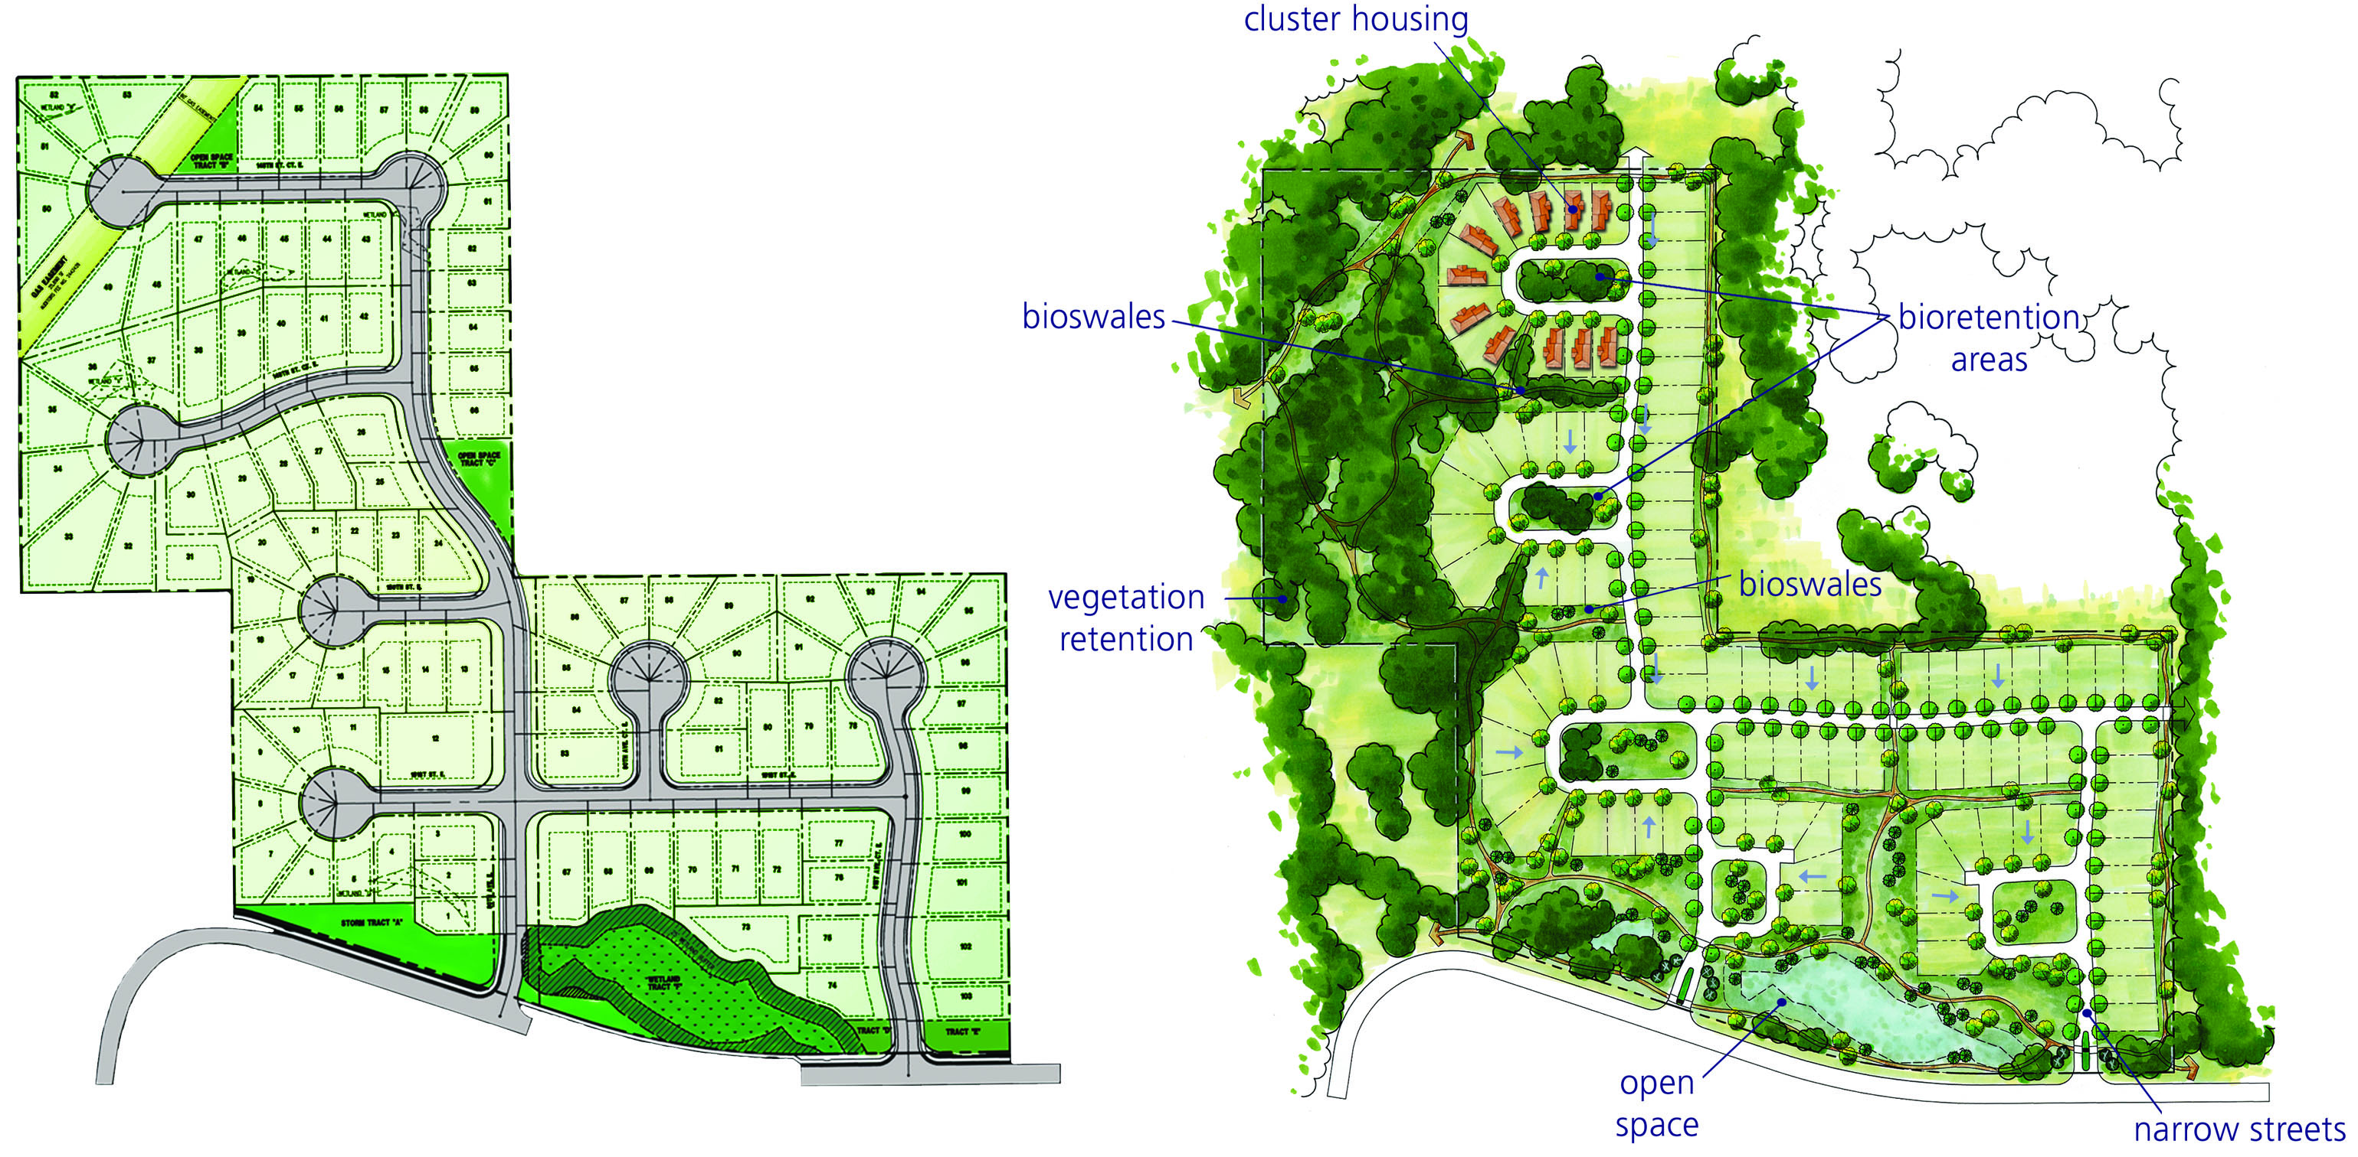

Is land conservation or impervious cover reduction a major goal or objective of the open space/cluster design regulations?

Are the submittal/review requirements for open space/cluster design greater than those for conventional development?

Are flexible site design criteria available for developers that utilize open space/cluster design options (setbacks, road widths, lot sized)?

Open Space Management
Does the community have enforceable requirements to establish associations that can effectively manage open space?

Are open space areas required to be consolidated into larger units?

Does a minimum percentage of open space have to be managed in a natural condition?

Are allowable and unallowable uses for open space in residential developments defined?

Can open space be managed by a third party using land trusts or conservation easements?

Tree Conservation
If forests or specimen trees are present at residential development sites, does some of the stand have to be preserved?

Setbacks and Frontages
Are irregular lots shapes (pie-shaped, flag lots) allowed in the community?

Is the minimum requirement for front setback in residential zones less than or equal to 20 feet?

Is the minimum requirement for rear setback in residential zones less than or equal to 25 feet?

Is the minimum requirement for side setback in residential zones less than or equal to feet?

Is the minimum lot frontage in residential zones less than or equal to 60 feet?

Rooftop Runoff
Can rooftop runoff be discharged to yard areas?

Do current grading or drainage requirements allow for temporary ponding of stormwater on front yards or rooftops?
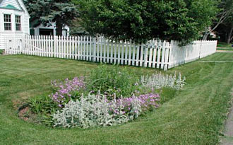

Are vegetated roofs allowed? Do criteria exist to allow designers to receive credit for landscaping, stormwater, etc. for the use of vegetated roofs?

Clearing and Grading
Do regulations require or encourage the preservation of natural vegetation at residential development sites?
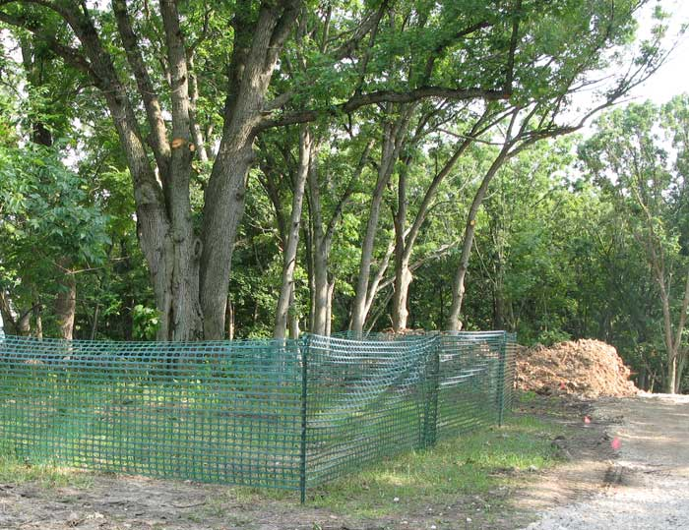

Stormwater Outfalls
Can stormwater be directly discharged into jurisdictional wetland without pretreatment?

Does a floodplain management ordinance that restricts or prohibits development within the 100-year floodplain exist?

Is stormwater required to be treated before it is discharged?

Are there effective design criteria for stormwater best management practices?

Potential Thresholds
Are there reviewable methods of determining and inspecting compliance with water quality standards?

Have hydromodification standards been adopted?

Does the hydromodification control standard require the management of runoff generated from the site’s impervious areas be contained on site?

Are runoff controls clearly specified?

Are mandatory source control measures defined?

Do drainage policies, standards and details allow for infiltration of stormwater or separation of directly-connected impervious areas?

If stormwater management is required, which redevelopment projects are required to meet the standard? What are the applicability thresholds for other development types?

Is there a maximum impervious area for specific land uses or zones?

Are "end of the pipe" facilities (proprietary stormwater quality treatment devices) allowed to be installed as stand-alone treatment?

Does databases exist which can send out inspection reminders for the long-term maintenance of stormwater BMPs?

Is a stormwater pollution prevention plan or other permit required as a condition of development?

Are maintenance agreement templates for stormwater quality facilities included in your engineering standards?

Other
Is stormwater quality a topic of the pre-applicant conference? Is a representative knowledgeable in stormwater obliged to attend? Is a stormwater management plan required as part of the preliminary plan review process?

Do applicants’ CEQA Initial Studies include analyses of the potential for discharge of stormwater pollutants from areas of material storage, vehicle or equipment fueling, vehicle or equipment maintenance (including washing), waste handling, hazardous materials handling or storage, delivery areas, loading docks or other outdoor work areas.

Gap Analysis Framework prepared by AHBL, Inc. from the following sources:
- Santa Clara Valley Urban Runoff Pollution Prevention Program Model Development Principles memo dated May 16, 2005
- Center for Watershed Protection Draft Code and Ordinance Worksheet
- Alameda Countywide Clean Water Program

